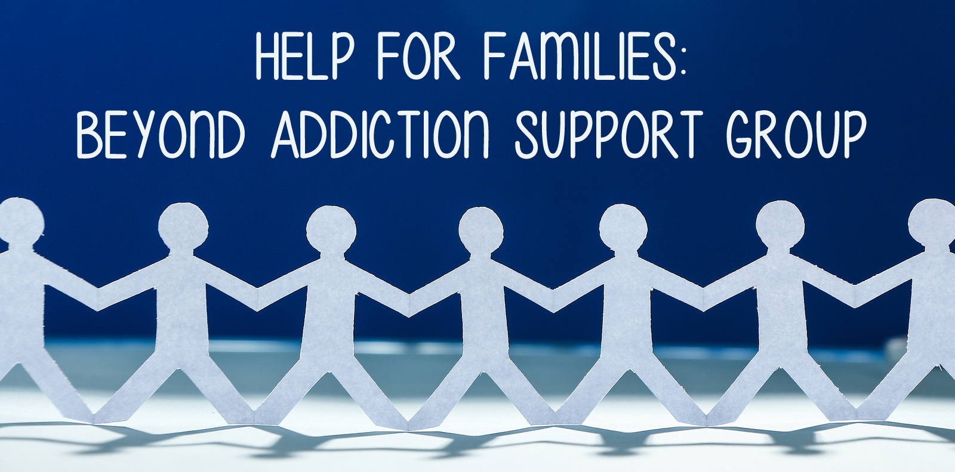

|  |  |
| --- | --- |
| |  | | --- | | Do you have a family member who struggles with substance abuse?  Are you feeling hopeless or overwhelmed because of a loved one’s addiction?  Would you like to better understand and communicate with your addicted loved one?  **BEYOND ADDICTION: A WEEKLY SUPPORT GROUP FOR PARENTS AND PARTNERS**  **Free and Open to Everyone Book study, videos and role plays. Drop in anytime!**  The goal of the group is to offer education, ways to communicate with addicted loved ones, as well as support for those who feel they have no place else to go. Through group discussions, role playing, videos and a book study, the support group offers evidence-based methods for families to help motivate and reinforce change for an addicted loved one. The focus of the group is how families can use collaboration and kindness rather than confrontation to support behavior change.   If you or someone you know is feeling hopeless in coping with a loved one's addiction, we encourage you to join us.    **When:**  **Time:   Location:**  **Contact: Cost: FREE** | |